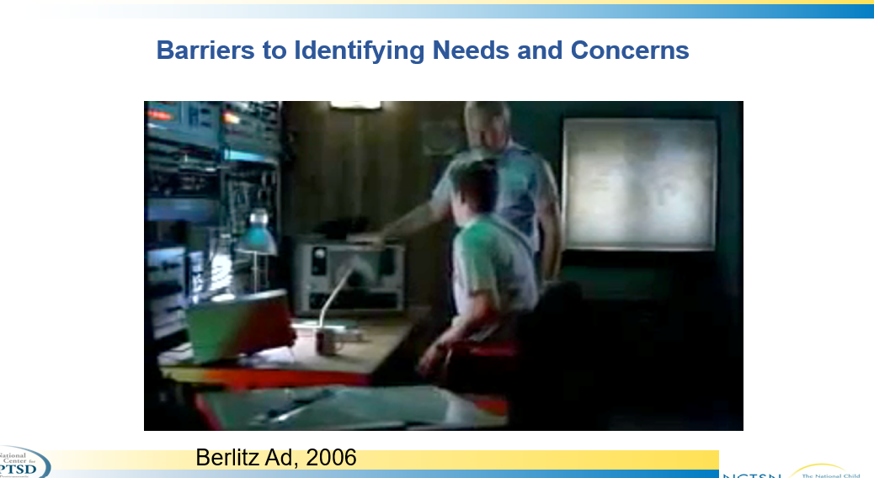

[Berlitz German Coastguard](https://www.youtube.com/watch?v=0MUsVcYhERY)

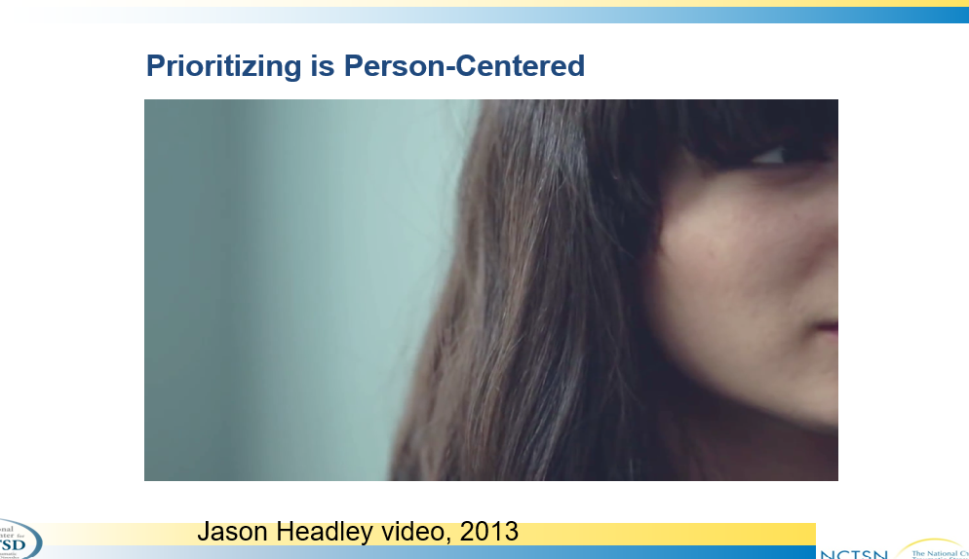

[It’s not about the nail](https://www.youtube.com/watch?v=-4EDhdAHrOg)

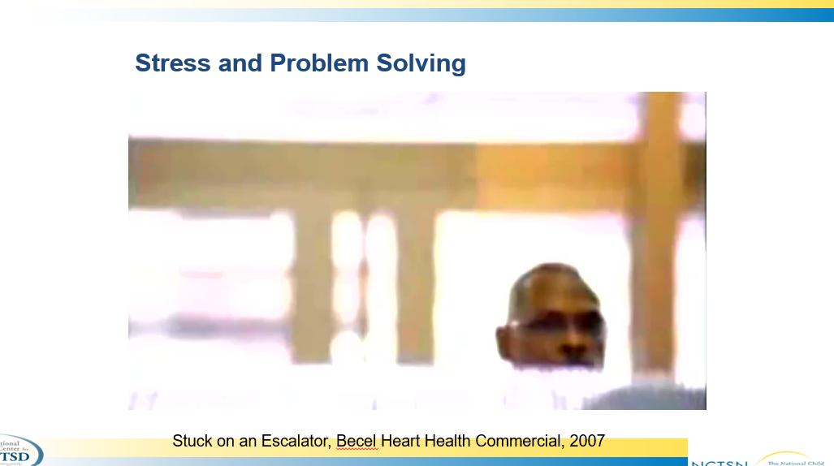

[Broken Escalator](https://www.youtube.com/watch?v=47rQkTPWW2I)

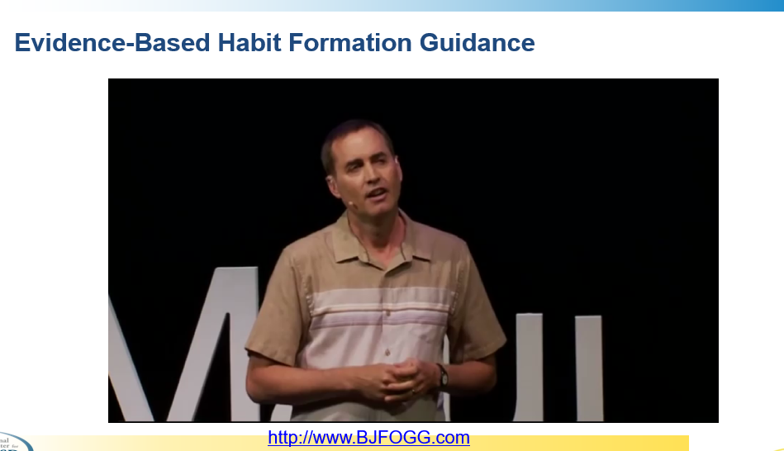

[Tiny surprises for happiness and health | BJ Fogg, PhD](https://www.youtube.com/watch?v=2L1R7OtJhWs)

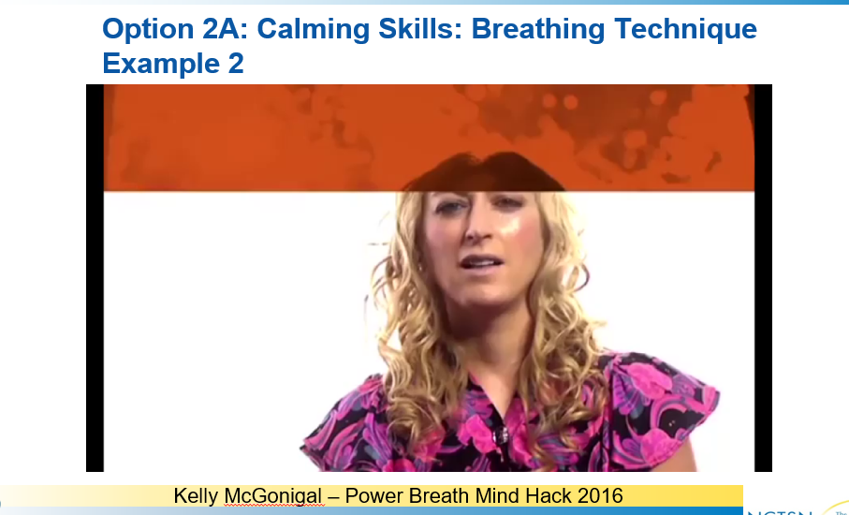

[Kelly McGonigal – Power Breath Mind Hack 2016](https://bigthink.com/videos/jane-mcgonigal-teaches-a-breathing-hack/)

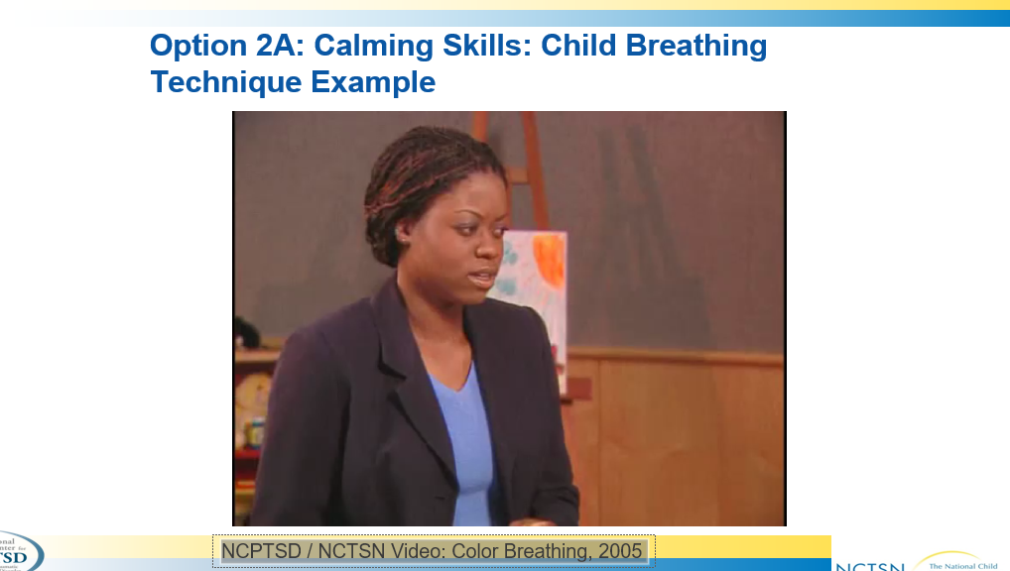

NCPTSD / NCTSN Video: Color Breathing, 2005 (Link only by permission - unavailable)

Consider alternatives: [Color Breathing - Everyday Speech](https://www.youtube.com/watch?v=N_EG3k2Lq7w)

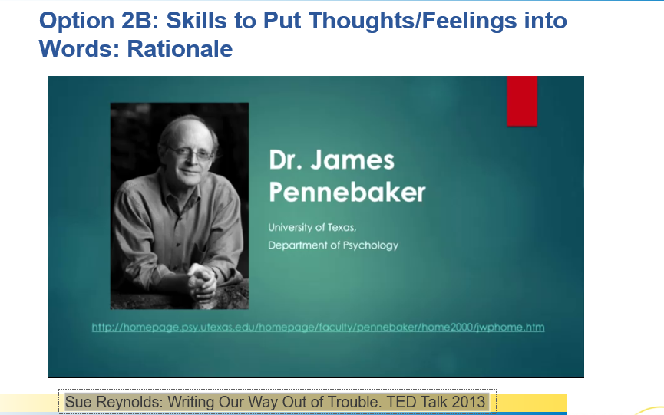

[Sue Reynolds: Writing Our Way Out of Trouble. TED Talk 2013 (FULL VERSION)](https://www.youtube.com/watch?v=kvb2QV0xMUs)

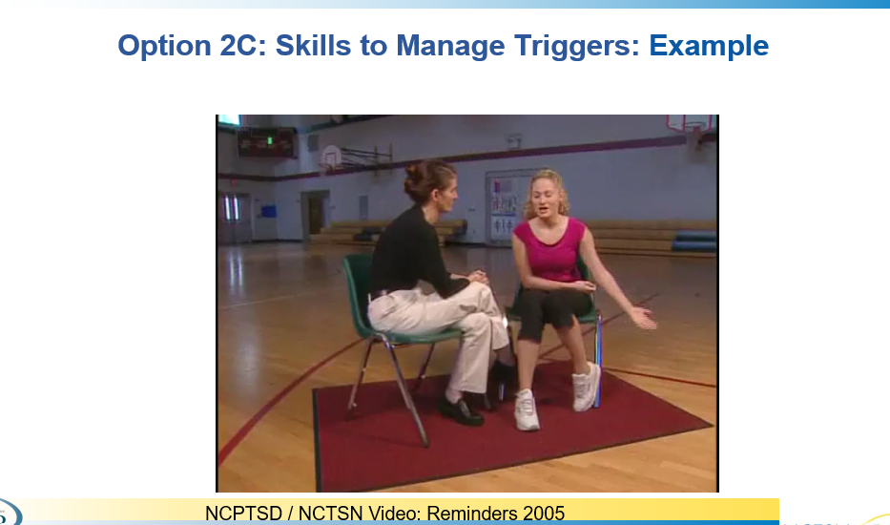

NCPTSD / NCTSN Video: Reminders 2005 (Link only by permission - unavailable)

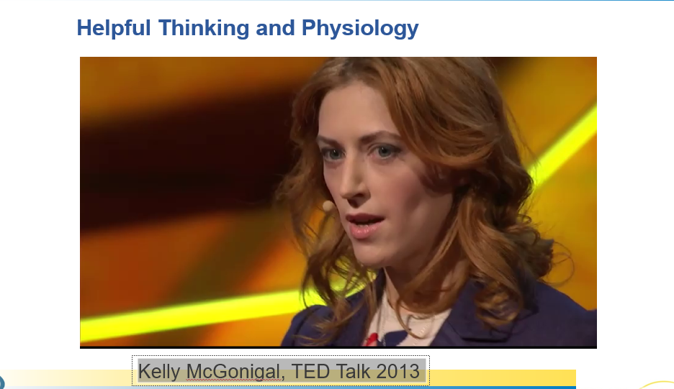

[Kelly McGonigal, TED Talk 2013](https://www.youtube.com/watch?v=RcGyVTAoXEU)

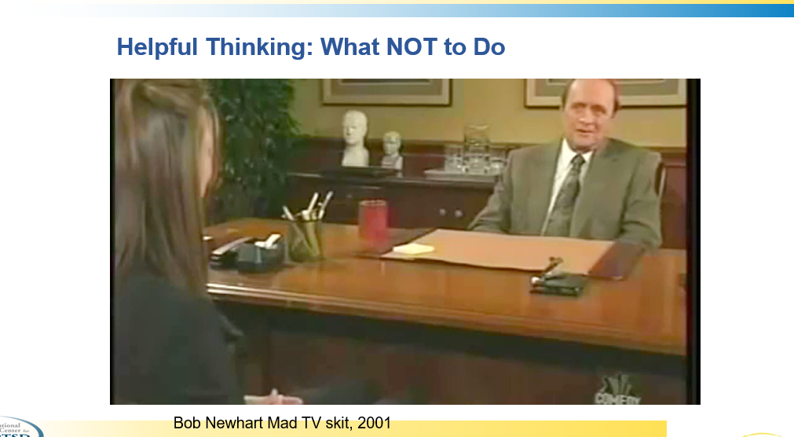

[Bob Newhart “Stop It!”](https://www.youtube.com/watch?v=bcSAQyzPcl0)

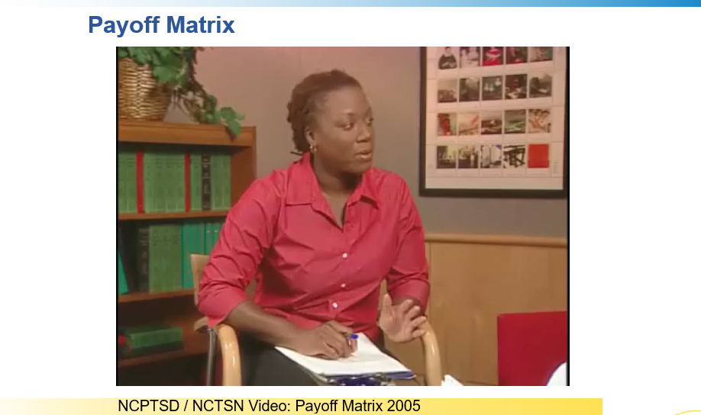

NCPTSD / NCTSN Video: Payoff Matrix 2005 (Link only by permission - unavailable)

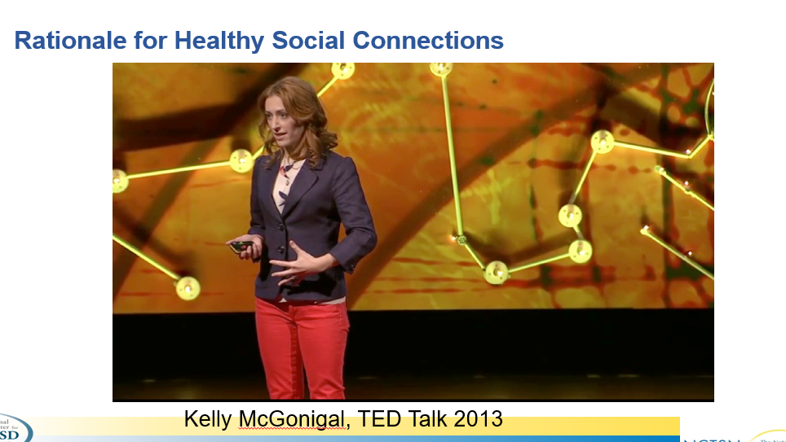

[Kelly McGonigal, TED Talk 2013](https://www.youtube.com/watch?v=RcGyVTAoXEU)

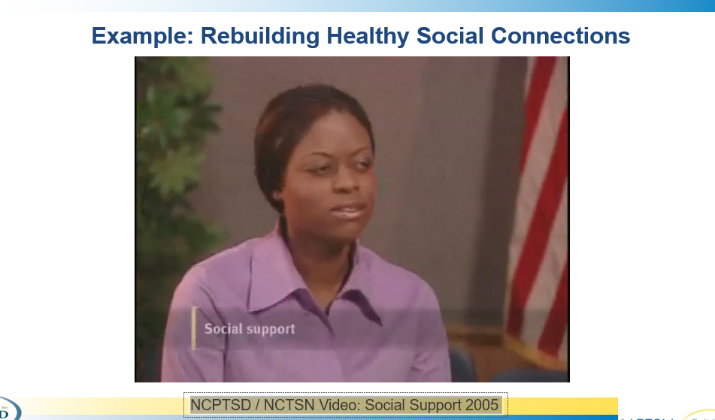

NCPTSD / NCTSN Video: Social Support 2005 (Link only by permission - unavailable)